**Age independent biometric verification from short heart beat signal**

**Davoodi et al. Beat to beat biometric verification**

Moran Davoodi1, Adam Soker1, Joachim A. Behar1 and Yael Yaniv1,*

1 Biomedical Engineering Faculty, Technion-IIT, Haifa, Israel

**\*Correspondence:**

Yael Yaniv, PhD  
Laboratory of Bioenergetic and Bioelectric Systems, Biomedical Engineering Faculty, Technion—IIT, Haifa

Email: [yaely@bm.technion.ac.il](mailto:yaely@bm.technion.ac.il)  
Phone: 972-4-8294124  
Fax: 972-4-8294599

**Abstract**

Automatic identity verification became more complicated with time due to new methods and techniques used for identity forging. Most of the solutions rely on biometric methods that are based on a biomarker matching which should be unique per individual such as fingerprints and face recognition which are highly vulnerable for forging. In order to overcome this limitation, biometric methods based on a non-stationary signals were suggested such as the heart activity recorded by an electrocardiogram (ECG). The complexity of the signals and their uniqueness do limit the ability to forge them but it is highly inefficient in terms of acquisition.

In this work, we present a novel biometric method which is based only on beat to beat information embedded within the time intervals between consecutive heart beats. This allows us to combine the benefit of non-stationarity along with easy, affordable acquisition. Moreover, this type of biometry relies on data with lower dimensionality compared to the ECG. We first present a Siamese convolutional neural network called RR-comp which is trained using constractive loss which was modified according the needs of verification. In the first experiment we show the effect of number of beats needed for the verification task achieving 11% EER over number of pairs tested. In the second experiment, we examined the effect of age on the performance of our model with pairs of the length of only 50 beats and we show that no significant change in the performance had occurred along 18 months which is equivalent to 60 human years. The model was trained only once at the age of 6 months. At the last experiment we show the effect of drugs administration and achieve 13% EER when the algorithm was trained and tested with mice data in the presence of drugs. We believe that this method can be used as an aided-biometry along with other existing biometrics and we also mention that it does not necessarily needs retraining when new subjects are added to the database.

# Introduction

In the last few decades there has been an increase use of biometric application for security identification, forensic evidence etc. Biometric is based on unique human characteristics including biological, physical and even behavioral ones. Various biometric technologies are available for identifying or verifying an individual such as by measuring fingerprint, hand or face geometry, hand-written signature, voice1 etc. However, the relative ease to forge those signals has made them limited biometrics in the aspect of reliability2,3.

The heart electrical signal is the strongest signal in the body and can be sensed even in the fingertip. In the last decade, the registration of the electrical activity of the heart by electrocardiogram (ECG) has been shown to be suitable for personal identification. 2,4–8. Currently, biometric recognition is based on 12-lead ECG. However, the 12-lead system is not user friendly and usually requires medical personnel to be set up. Although an approach to move toward single-lead acquisition was developed,10,11 a pair of electrodes are still needed. Two electrodes may be affordable but a person still needs to be in a physical contact with a device for biometric recognition. Beat-to-beat interval of heart rate can be measured by compact wearable devices such as watches or wristbands and even remotely by video cameras.9 Moreover, it reduces substantially the data dimensionality needed for verification in comparison to ECG. Beat-to-beat variability may reflect the uniqueness of physiological systems that contribute to its behaviors.

In our work, we aim to design a biometric verification method that is based on heartbeat interval only. Our method is based on heartbeat interval which are the time interval between consecutive R peak in the ECG signal. Note that any device that provides information on beat interval can theoretically be used. In real-life biometric, we would have a database of biometric signatures based of course on heartbeat intervals. Once a subject claim to be person “A”, the algorithm would track the biometric signature of “A” in the database and compare it to the current biometric signature using a neural network. Before using the neural network for the first time, we must acquire the database and then train the network with it. Once we completed the training, the neural network should be able to compare and make decisions for also new subject that were added to the database with no retraining. Thus, the system should perform well in both conditions. Moreover, biometric signature is calibrated seldomly, age should have only weak effect on the performance. Finally, due to the wide use of medications around the world, we would like to examine the effect of drug administration on the verification task performance.

# Results

# The effect of number of heartbeat intervals on the ability to perform biometric recognition

In this section we first examined the dependence of biometric verification performance on the number of heartbeats. We used two different training processes. In the complete dataset (CD) approach, we trained a neural network with heartbeat window pairs from all mice data and evaluated the performance on unseen heartbeat window pairs. In the partial dataset (PD) approach, we trained the model on the entire heartbeat window pairs of some mice and tested on heartbeat window pairs of unseen mice. All trained data were from 6 months old mice and in this section, the tested data was also from mice at the same age. Fig. 1 shows the equal error rate (EER, see definition in method section) for both approaches. Lower EER indicates on a better performance. The minimal EER was 0.11 in CD experiment and 0.23 in PD experiment. These results indicate on a substantially better performance in the CD experiment as expected. Note, that minimal EER was achieved at different heartbeat window lengths for the two approaches (400 beats for CD and 100 beats for PD). For other performance measures see Table 1.

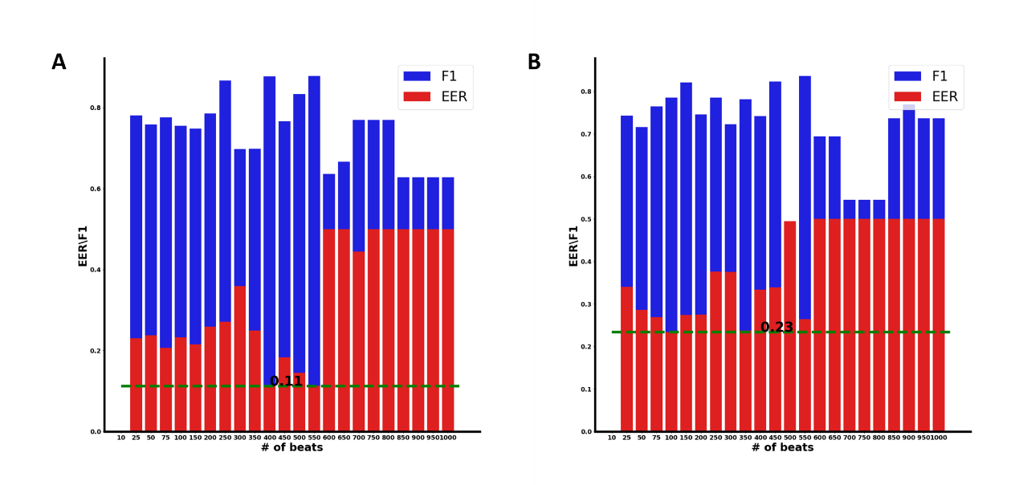

**Figure 1: Equal error rate (EER) as function of the heartbeat window length.** Biometric verification performance on the test set measured by EER at different heartbeat window lengths after the model was trained with (A) complete dataset approach (CD) and (B) partial dataset (PD).

# The effect of age on the biometric verification performance

Biometric signature is learned ideally once or at least calibrated seldomly. Thus, age should have only weak effect on the performance. To examine the robustness of our method, we trained the model in either approach on 6 months heartbeat window pairs and tested it on unseen heartbeat window pairs from other ages. Each heartbeat window length was 50 beats long. This provided a sufficient number of heartbeats to have good performance of biometric verification on the one hand (see Fig. 1) and on the other hand it is feasible to acquire and use in practical aspects including in humans.

Fig. 2 shows the EER for both approaches. For the CD experiment, the minimal EER of 0.23 was achieved at 6 months and did not significantly change with age. In the PD experiment, minimal ERR of 0.16 was achieved at 18 months and was lower than the EER achieved at 6 months (p=xx). Moreover, at this condition there was an age dependence. For other performance measures see Table 2.

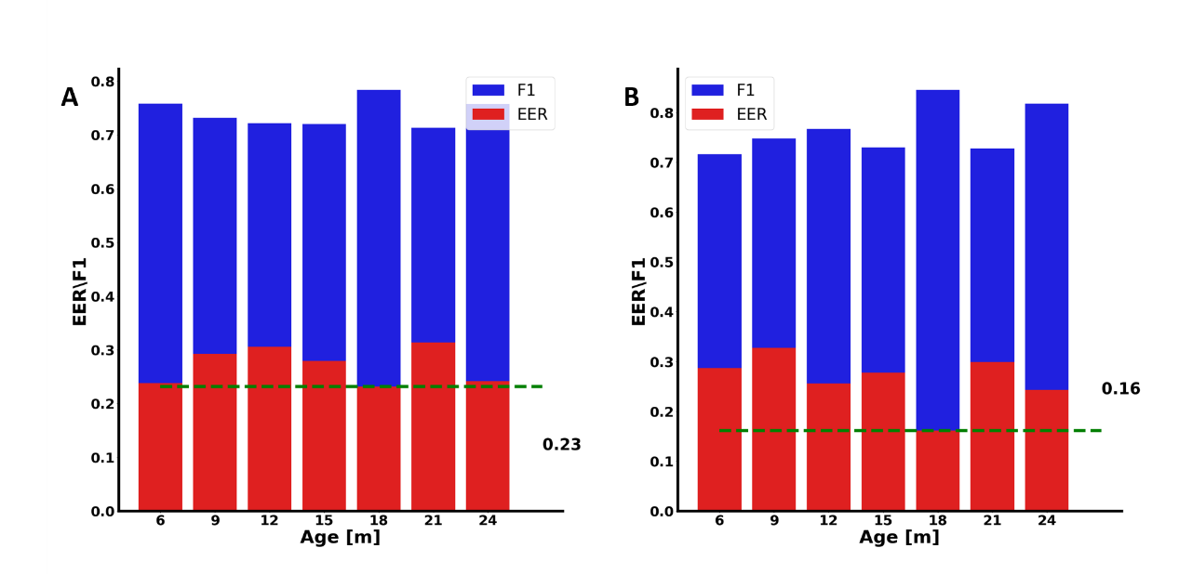

**Figure 2: Equal error rate (EER) as function of age.** Biometric verification performance on the test set at different ages measured by EER after the model was trained with (A) complete dataset (CD) approach and (B) partial dataset (PD). The models were trained with heartbeat window pairs at the age of 6 months old only.

# The effect of drug administration on the ability to perform biometric verification

As mentioned, biometric signature is learned mostly once, but medications are used in everyday situation and they are well common. Thus, we examined the performance of our method when tested on heartbeat windows pair from mice that were admitted with drugs. We chose to use drugs that affect the heartbeat dynamics by interfering with autonomic nervous system (ANS) input to the heart. In the first experiment (using CD approach), we simulated the condition where the biometric signature was learned without drugs and the biometric verification was performed in the presence of drugs. Fig. 3A shows that minimum EER of 0.21 was achieved for heartbeat window of 200 beats. We note that when compared to the performance evaluated on mice with no drug administration as in Fig. 1A, the EER was half than our current result. In the second experiment (using CD approach), we simulated the conditions where the biometric signature was learned in the presence of drugs and the biometric recognition was performed in the presence of drugs as well. Fig. 3B shows that the minimal EER of 0.13 achieved for heartbeat window length of 400 beats. Note that this result is similar to the experiment where we trained the model without drugs and evaluated the performance without drugs as in Fig. 1A. We came to similar conclusions a PD approach was used (Fig. S1). In the third experiment (using CD approach), we simulated the conditions where the biometric signature was learned on data that was recorded with and without the presence of drugs and was performed in the presence of drugs. It is important to note that the mice that received the drugs and the ones who did not are the same mice as explained in the supplementary material. In addition, each pair was composed from heartbeat windows under the same condition (with drug or without drug). Fig. 3C shows that minimum EER of 0.23 achieved for heartbeat window of 100. Under these conditions, the system performance is poor. Similar conclusion was deduced also when we tested the model performance on a combined dataset in both CD and PD approaches as can be seen in Fig. S2.

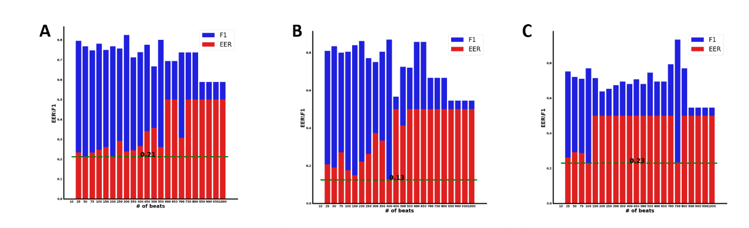

**Figure 3: Dependence of equal error rate (EER) performance on drug administration using complete dataset (CD) approach.** Biometric verification performance on the test set measured by EER for trained model on (A) heartbeat windows without drug, (B) heartbeat windows with drug and (C) combined heartbeat windows with and without drug. All were tested on heartbeat window with drug. Mice at both train and test setswere 6 months old.

# The effect of drug administration and on the ability to perform biometric verification with growing age

Similar to the approach we used without drug administration, we examined the robustness of our methods, by training the data in either approach on 6 months heartbeat windows and tested it on heartbeat windows from other ages that included drugs. We used here window pairs of 50 heartbeats for the same reasons mentioned above.

In the first experiment (using CD approach), we simulated the conditions where the biometric signature was learned without drugs at age of 6 months and the biometric verification was performed in the presence of drugs for different ages. Fig. 4A shows that minimum EER of 0.2 achieved at age of 6 months as expected. Until 18 months there is no age-dependent of EER. In the second experiment (using CD approach) we simulated the conditions where the biometric signature was learned with drugs at age of 6 months and the biometric recognition was performed in the presence of drugs for different ages. Fig. 4B shows that minimum EER of 0.19 also achieved at age of 6 months and does not change significantly by age. Note, that this behavior is close to the condition where we trained and tested without drugs (Fig. 2A). In the third experiment (using CD approach), we simulated the conditions where the biometric signature was learned on data from mice with and without drugs at age of 6 months and the biometric verification was performed in the presence of drugs for different ages. Fig. 4C shows that the EER did not change significantly for 6 months old, but the system performance is poor either way.

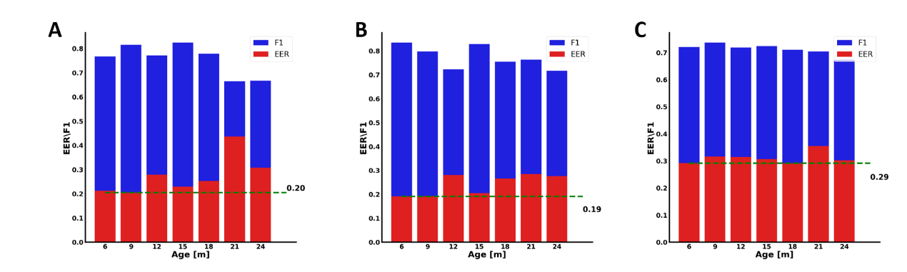

**Figure 4: Equal error rate (EER) performance as a function of age in the presence of drugs using complete dataset (CD) approach.** Biometric verification performance on the test set measured by EER for trained model on (A) heartbeat window pairs without drug, (B) heartbeat window pairs with drug and (C) combined heartbeat window pairs with and without drug. All were tested on heartbeat window with drugsandall were trained heartbeat window from 6 months.

# Discussion

Biometric verification is widely used for security-based applications. However, some of the biometric methods are either easy to forge or require high cost for expensive devices. This work demonstrated that a biometric verification method based on heartbeat interval only can perform well under real world limitations. The system can perform verification on subjects whether they were part of the training process or added to the database after training and thus they are completely new to the system. Moreover, our method is not aged-dependent. The biometric signature was learned at the age of 6 months (equivalent to 20 human years) and was used for verification until the age of 24 months (equivalent to 80 human years). In addition, the method performs well whether the calibration and test were performed with or without drugs. Therefore, such method can be used as aided biometric agent for verification tasks.

As expected, throughout all of the experiments, we always achieved better performance when we trained over all of the mice and evaluate on unseen heartbeat windows (i.e., the CD approach). Although both conditions can happen in reality, the PD experiment is more complicated because it requires a very high level of generalization and the ability to learn the overall mechanism of comparison. Note that even when the hyperparameters seen in Table S1 were tuned for PD assignment they still performed better in CD. When evaluating dependence of the EER on the number of heartbeats in the window (Fig. 1), we found in both CD and PD performance a “U” shaped trend. The minimal EER occurs at the range of 300-550 beats in CD and 25-250 beats in PD. Failure (EER=0.5) occurs around 600 beats at both cases. In general, we would like it to be low so data acquisition and biometric inference will be quick. On the other hand, a unique pattern will be more likely to be discovered in longer signals because in a long signal we can reveal its dynamics. However, we assume that the signal is not stationarity within a window if the latter is too large. Thus, a longer heartbeat window provides more information and may improve the results. On the other hand, because data stationarity and the decrease in number of trained windows, longer heartbeat windows will damage the performance. Note, that because the number of heartbeat windows was equal with and without drugs and the failure happen at different lengths, the signal stationarity is probably the main reason for the “U” shape rather than the number of windows in the training process.

Biometric signature is learned ideally once or at least calibrated seldomly. Thus, age should have only weak effect on the performance. This is an important aspect because it is well known that heartbeat dynamic changes with age10. In Fig. 2 the model was trained on heartbeat windows at 6 months old and tested over older ages. We expected to achieve the minimal EER at the age of 6 months. However, we achieved it under PD conditions at the age of 18 months. Note that in general our variance was low between ages, thus we can conclude that our verification method is not aged dependent.

We tested the performance of our method when drug was administrated in three different cases (Fig.3). When the learning and testing data were composed of heartbeat windows in the presence of drugs (Fig.3B), the performance was quite similar, up to a shift, to the case when learning and testing data contained no drugs as in CD case shown in Fig. 1. This can indicate that as long as the learning was performed in a single condition it would be valid to this condition. The shift which made the “U” shape move is probably related to the fact that the drugs that we used express variability mechanisms in the long term. Another evidence supporting the importance of the given condition is shown Fig.3A, where we can see that the performance was damaged when the signature was learned using data which did not contain any drug but evaluated on heartbeat windows in the presence of drugs. Thus, for these subjects a new calibration should be performed. From Fig.3C we can again conclude that we cannot combine these two type of populations in the learning process. As expected, the same trends occurred also when we tested these conditions and the effect over age as can be seen in Fig.4.

We verified our methods on mice data. Note, that these mice are genetically related and therefore the performance that achieved should be lower than non-relative individuals. However, our unique dataset allows to test the effect of aging and drugs administration on biometric verification that was poorly tested before.

The results show that using only the heartbeat window pairs and a simple Siamese network composed only from convolutional and linear layers, a verification of mice identity can be performed. According to Ingale et. al11, the EER measure achieved by ECG-based methods that was tested on human are superior to our results. Nevertheless, our method holds the advantage of the ability to extract our signal without having an expensive ECG device which is also complicated to connect. Heartbeat window can be extracted in many ways such as smart watches, photoplethysmogram (PPG) and even remotely by video camera. Another important benefit is the substantial dimensionality reduction achieved using our method. For example, a heartbeat window with fixed 250 beats have an average duration of 33 sec in mice. In comparison, the ECG used for peak detection was sampled at 10 KHz. Thus, an equivalent ECG window would have on average 335,000 samples. With a beat window containing only 250 samples (beats) we manage to reduce dimensionality by 1,340.

**Methods**

**General approach**

The main goal of our work was to provide a proof of concept that biometric verification can be performed only from heartbeat intervals time series. In biometric tasks, verification is where we compare a pair of input signals and should estimate whether the signals composing the pair belong to the same subject or not. In order to accomplish our goal, we used two different training processes. In the complete dataset (CD) approach, we trained a neural network with heartbeat window pairs from all subject data and evaluated the performance on unseen heartbeat window pairs. This approach simulates verification process on a subject that was a part of the databased used for training. In the partial dataset (PD) approach, we trained the model on the entire heartbeat window pairs of some subject and tested on heartbeat window pairs of unseen subjects. This approach simulates verification process on a subject that was not a part of the databased used for training.

We also examined the robustness of our method to age. Biometric signature is learned ideally once or at least calibrated seldomly. Thus, age should have only weak effect on the performance. Thus, we always trained our algorithm on mice data of 6 months (see below) and tested on other ages.

### Dataset

The original dataset is composed of 58 C57/BL6 mice ECG recordings and their adequate heartbeat signals published in Moen et. al12. This study was performed in accordance with the Guide for the Care and Use of Laboratory 102 Animals published by the National Institutes of Health (NIH Publication no. 85–23, revised 1996). Experimental protocols were approved by the Animal Care and Use Committee of the National Institutes 104 of Health (protocol #441-LCS-2016).

Mice were anesthetized with 2% isoflurane (Baxter Corp) at rate of 0.2 ml/min and electrode needles were inserted under the skin. Data was analyzed from the beginning of the recording (at least 20 min after anesthesia). ECG was recorded using Power Lab 6, with signals obtained at a sampling rate of 10[KHz]. A three-lead electrocardiograms were recorded at constant temperature (25°C) and humidity (44%)for 10 min under basal state (i.e. no drugs) and 40 min after injection of a saline solution containing (400 µl for 30 g) Atropine (75[$μg/ml$]) and Propranolol (150[$μg/ml$]) (i.e. denoted as drugs). During recordings, a heat lamp was positioned at a constant distance (approximately 25 cm) from the mouse’s body to prevent heat loss. Starting at 6 months of age and continuing for the entire life span of each mouse, ECG time series were recorded in each mouse at 3-month intervals until the age of 24 months to evaluate the verification feasibility as a function of age. We wanted to have all the mice recordings in the evaluation process to be present so we excluded all the mice who lived less than 24 months. Overall, from 58 mice, we were left with 30 mice.

The duration of the basal state was always much shorter than the “drug” state. For a balance compression, the mouse with the minimal number of windows in the basal state defined the number of heartbeat windows (n=x). For mice with larger number of heartbeat windows we selected the first N in both basal and “drug” state.

### Dataset pre-processing

We used only the heartbeat intervals as input to our system. Heartbeat interval were extracted using PhysioZoo13. Heartbeat interval segments extracted from the ECG recordings using peak detector named "wjqrs" implemented in PhysioZoo. The heartbeat windows were non-overlapping.

We have excluded the first 2 min of the “drug” segments to avoid transients. We used the ranged based filtering from PhysioZoo13. The filter range was defined as 0.05–0.24 s, corresponding to specific heart rate ranges of 250–1,200 bpm.

### Neural network

The verification model was based on a variation of Siamese network14. In our network, our inputs are heartbeat window pairs. They can either belong to the same mouse and then they are considered as positive pairs or they can belong to different mice and then they are considered as negative pairs. Each minibatch consisted of 50% of positive pairs and 50% negative pairs.

The model contained 3 convolutional layers followed by batch normalization and MaxPooling (n=2) and activated by a rectified linear unit(ReLU). These layers had the same kernel size which was equal to $\frac{1}{10}$ of the heartbeat window length. Then we had 3 linear layers regularized by dropout followed by batch normalization and activated by ReLU except the last layer that was only linear. The learning rate and batch size were adjusted to each condition (no drug, drugs or combined) by Bayesian search15 and described in Table S1.

**Training process**

We introduce a modified constractive loss function that is based on cosine similarity, i.e. we measure the angle between the embedded vectors. The mean batch loss function over B pairs is as follows:

$$\left(1\right) L\left(Θ\right)=\frac{1}{B}\sum_{i=1}^{B}{\left(1-y^{\left(i\right)}\right)}c\left(x_{1}^{\left(i\right)},x_{2}^{\left(i\right)};Θ\right)-λy^{\left(i\right)}\left(b+c\left(x_{1}^{\left(i\right)},x_{2}^{\left(i\right)};Θ\right)\right)$$

$$y^{(i)}=\left\{\begin{matrix}1 & if tag\left(x_{1}^{\left(i\right)}\right)=tag\left(x_{2}^{\left(i\right)}\right) \\ 0 & otherwise\end{matrix}\right.$$

$$c\left(x_{1}^{\left(i\right)},x_{2}^{\left(i\right)};Θ\right)=\frac{f^{T}\left(x_{1}^{\left(i\right)};Θ\right)f\left(x_{2}^{\left(i\right)};Θ\right)}{{\left\|f\left(x_{1}^{\left(i\right)};Θ\right)\right\|}_{2}{\left\|f\left(x_{2}^{\left(i\right)};Θ\right)\right\|}_{2}}=cos\left(γ\right)$$

$tag\left(x_{1}^{\left(i\right)}\right)=tag\left(x_{2}^{\left(i\right)}\right)$ means that the first component of pair number $i$ came from the same mouse as the second component. $f$ is the Siamese network parameterized with learnable $Θ$. $c\left(x_{1}^{\left(i\right)},x_{2}^{\left(i\right)};Θ\right)$ represents the cosine similarity calculated as the normalized inner product between the two embedded vectors $f\left(x_{1}^{\left(i\right)};Θ\right),f\left(x_{2}^{\left(i\right)};Θ\right)$ in the latent space. It also represents a measure of the "angle" between them, denoted here as $γ$. We added the terms $λ>0$ and $b∈[-1,1]$ to control the tradeoff between false acceptance rate (FAR) and false rejection rate (FRR). $b$ defines whether FAR or FRR is more important and $λ$ tells how important that measure is. If $b>0$, then FRR is more important and if $b<0$, FAR is more important. We set $b$ and $λ$ as hyperparameters and search for the optimal ones that would minimize the loss function. A visualization of the loss function with the minimal and maximal values of $b$ can be seen in Fig. S3.

We tuned the hyperparameters of the model in every condition (no drugs, drugs or combined) separately by using Bayesian search15. The hyperparameters tuned within the models and written in Table S1 were: batch size, dropout, learning rate, optimizer's momentum and weight decay, number of epochs and also $b,λ$ (eq. (1)) as mentioned above.

These hyperparameters were tuned according to heartbeat window length of 250 beats for every condition (no drugs, drugs or combined) separately and applied over all of the different heartbeat window lengths from 25 to 600 beats.

The preparation of the CD experiment included a partition of all of the 6 months old mice into training and testing windows with a ratio of 80%-20% respectively. The training set is also splitted with 80%-20% ratio. Note, that because the number of heartbeat windows decreases with the increase of the heartbeat window length, there were cases where we had mice with only one single heartbeat window in the testing set. Thus, the positive pair of these specific mice had to contain two identical signals. The percent of such windows in neglectable up to heartbeat window length of 600 beats.

For PD experiments, we set the training, validation and testing set to contain different mice. In the age of 6 months, the training set included 20 mice, the validation set included 5 mice and testing set had 5 mice.

**Model evaluation and statistical methods**

For each experiment, we compare pairs of heartbeat windows. We define the label of a negative pair as 0 and positive as 1. In the confusion matrix, $C∈N^{2×2}$, the rows represent the ground truth labels and the columns represent the predictions. To predict whether a pair is positive or negative, we need to set a threshold for $c\left(x_{1}^{\left(i\right)},x_{2}^{\left(i\right)};Θ\right)$ which can range in. This is equivalent to set a threshold to the angle between the embeddings. If the angle between the embeddings of the pair’s components is larger in absolute value than the threshold than it would be considered as negative and if it is smaller it would be considered as positive. The FAR and FRR are a function of the threshold. These measures are equivalent to false negative rate and false positive rate respectively if we define a positive pair as a pair of signals that belong to the same mouse and a negative pair if they belong to different mice.

In biometry verification statistics, it is common to report equal error rate (EER)16 which corresponds to the value of FPR and FAR when they are equal.

A way to visualize wellness of performance is shown in ‎Fig. 5 where we used the drug model and tested with window length of 25 heartbeat. We measure the cosine distance between each pair of the embeddings in the latent space. A negative pair should tend to be closer to -1, whereas a positive pair should tend to be closer to +1. The decision boundary is a threshold in the range of [-1, +1].

Add other measures

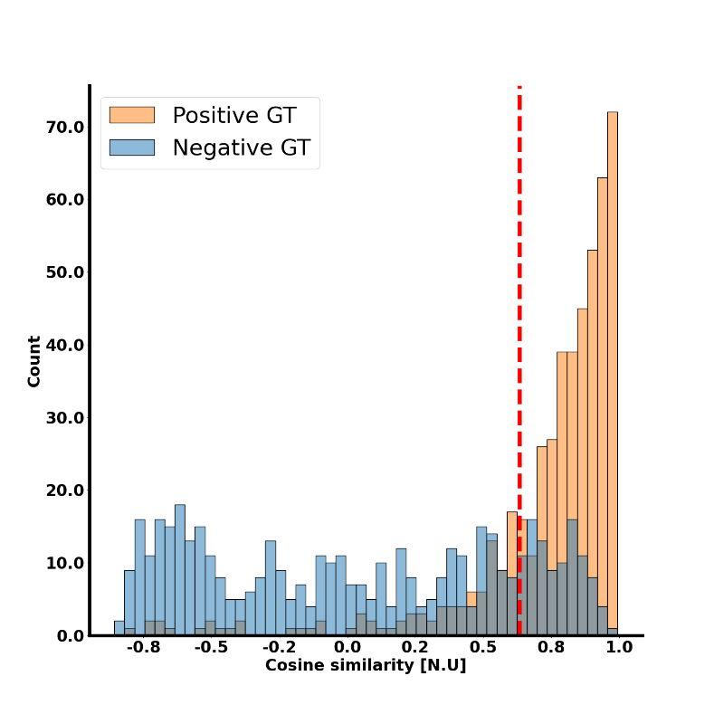

Figure 5. **A visualization of the classification task.** The decision boundary is shown as a red dashed line. The orange and blue colors are for ground true labelling of pairs. A perfect classifier would have only orange examples to the right of the threshold and only blue examples to the left of it.

# References

1. Xiao, Q. Technology review - Biometrics-Technology, Application, Challenge, and Computational Intelligence Solutions. *IEEE Comput Intell Mag* **2**, 5–25 (2007).

2. Wu, Q., Yan, B., Zeng, Y., Zhang, C. & Tong, li. Anti-deception: Reliable EEG-based biometrics with real-time capability from the neural response of face rapid serial visual presentation. *Biomed Eng Online* **17**, (2018).

3. Busch, C. & Sousedik, C. Presentation attack detection methods for fingerprint recognition systems: A survey. *IET Biom* **3**, 219–233 (2014).

4. Vieau Sarah and Iaizzo, P. A. Basic ECG Theory, 12-Lead Recordings, and Their Interpretation. in *Handbook of Cardiac Anatomy, Physiology, and Devices* (ed. Iaizzo, P. A.) 321–334 (Springer International Publishing, 2015). doi:10.1007/978-3-319-19464-6_19.

5. Sulam, J., Romano, Y. & Talmon, R. Dynamical system classification with diffusion embedding for ECG-based person identification. *Signal Processing* **130**, 403–411 (2017).

6. Lynn, H. M., Pan, S. B. & Kim, P. A Deep Bidirectional GRU Network Model for Biometric Electrocardiogram Classification Based on Recurrent Neural Networks. *IEEE Access* **7**, 145395–145405 (2019).

7. Zhang, Q., Zhou, D. & Zeng, X. HeartID: A Multiresolution Convolutional Neural Network for ECG-Based Biometric Human Identification in Smart Health Applications. *IEEE Access* **5**, 11805–11816 (2017).

8. Bak, E., Choi, G.-H. & Pan, S. B. ECG-Based Human Identification System by Temporal-Amplitude Combined Feature Vectors. *IEEE Access* **8**, 42217–42230 (2020).

9. Wu, H.-Y. *et al.* Eulerian Video Magnification for Revealing Subtle Changes in the World. *ACM Trans. Graph. (Proceedings SIGGRAPH 2012)* **31**, (2012).

10. Yaniv, Y. *et al.* Deterioration of autonomic neuronal receptor signaling and mechanisms intrinsic to heart pacemaker cells contribute to age-associated alterations in heart rate variability in vivo. *Aging Cell* **15**, 716–724 (2016).

11. Ingale, M., Cordeiro, R., Thentu, S., Park, Y. & Karimian, N. ECG Biometric Authentication: A Comparative Analysis. *IEEE Access* **8**, 117853–117866 (2020).

12. Moen, J. M. *et al.* Emergence of heartbeat frailty in advanced age I: perspectives from life-long EKG recordings in adult mice. *Geroscience* **44**, 2801–2830 (2022).

13. Behar, J. A. *et al.* PhysioZoo: A Novel Open Access Platform for Heart Rate Variability Analysis of Mammalian Electrocardiographic Data. *Front Physiol* **9**, (2018).

14. Bromley, J. *et al.* Signature Verification using a ‘Siamese’ Time Delay Neural Network. *Intern J Pattern Recognit Artif Intell* **7**, 25 (1993).

15. Biewald, L. Experiment Tracking with Weights and Biases. Preprint at https://www.wandb.com/ (2020).

16. Teh, P. S., Zhang, N., Teoh, A. B. J. & Chen, K. A survey on touch dynamics authentication in mobile devices. *Comput Secur* **59**, 210–235 (2016).

# Supplementary material

###### 

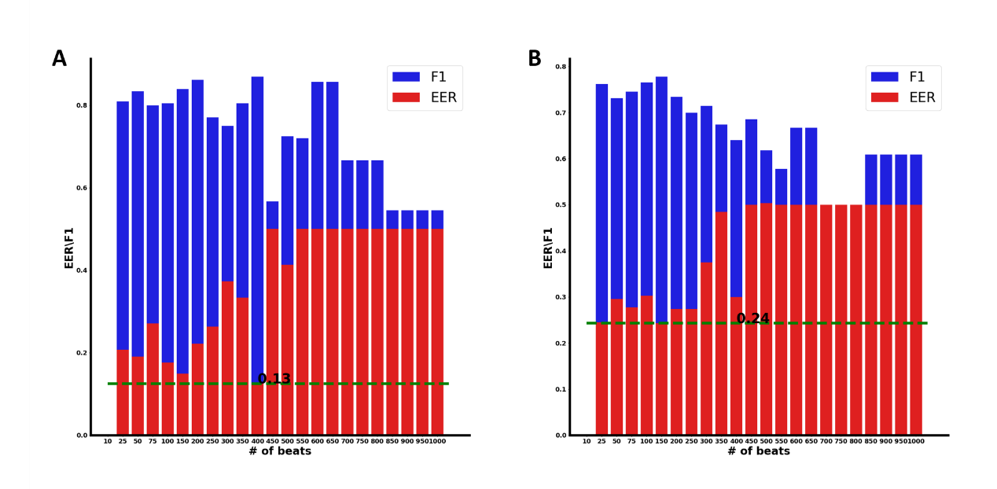

**Figure S1: Equal error rate (EER) as function of the heartbeat window length in the presence of drugs**. Biometric verification performance on the test set measured by EER for both (A) complete dataset approach (CD) used for training and (B) partial dataset (PD) used for training at different heartbeat window length in the presence of drugs.

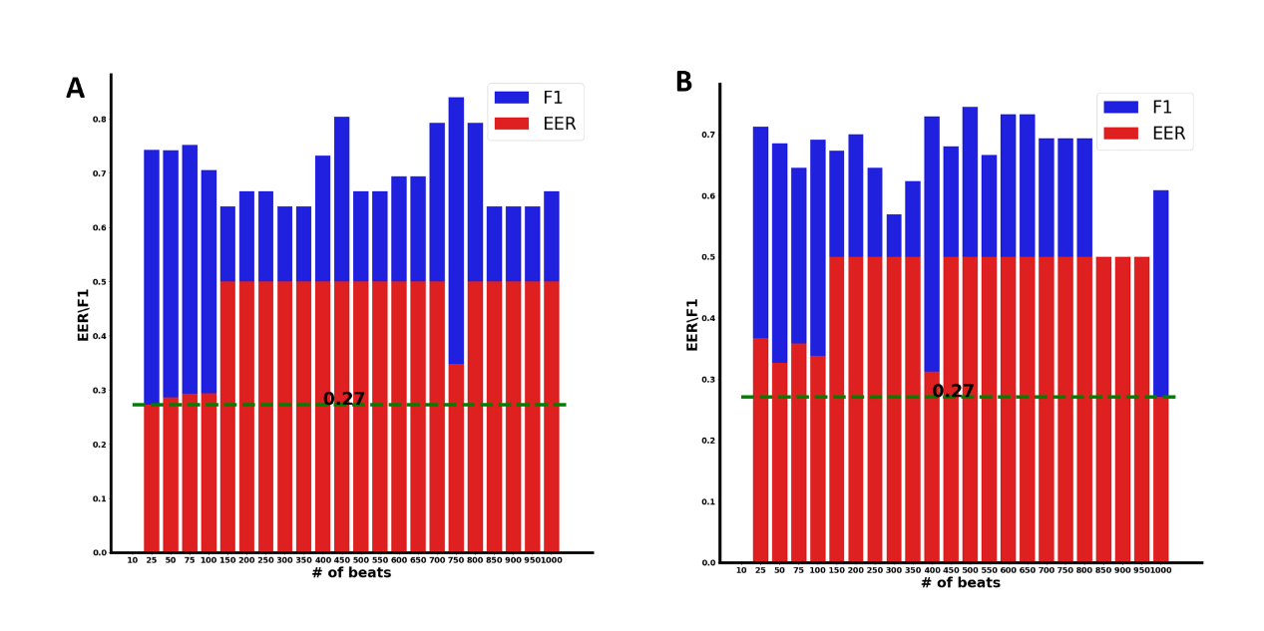

**Figure S2: Equal error rate (EER) as function of the heartbeat window length when trained and tested on data with and without the presence of drugs.** Biometric verification performance on the test set measured by EER for both (A) complete dataset approach (CD) used for training and (B) partial dataset (PD) used for training at different heartbeat window length.

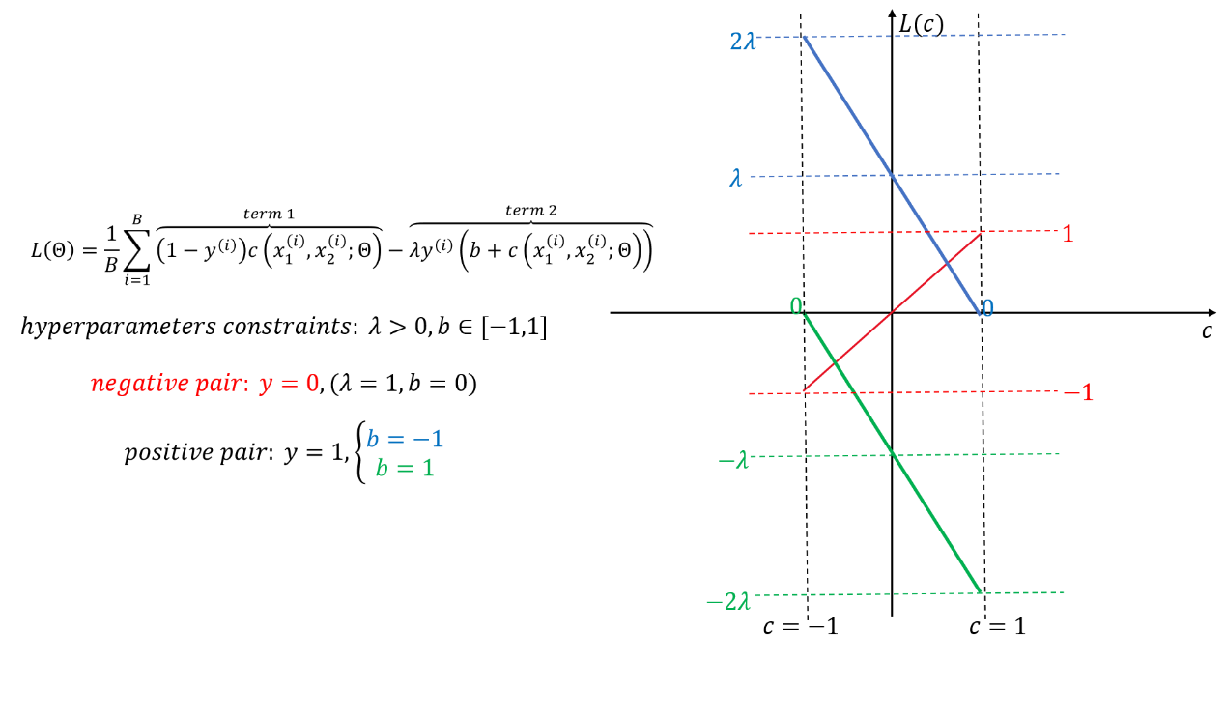

**Figure. S3. Schematic description of the lost functio**n. The loss is composed of two terms. A term is activated according to the label of the pair. If the pair is negative, the loss function activated on this pair is the red one. If the pair is positive, a linear monotonic decreasing function is activated. The linear function is parallel to and in between the blue and green linear functions depending on the value of $b$.

Tables:

**Table. S1 Hyperparameters tuning.**

|  |  |  |  |  |  |  |  |  |
| --- | --- | --- | --- | --- | --- | --- | --- | --- |
|  | batch size | dropout | learning rate | momentum | weight decay | epochs | $$b$$ | $$λ$$ |
| No drug | 8 | 0.12 | 3.4e-7 | 0.75 | 1.17 | 200 | 0.47 | 9.61 |
| Drug | 16 | 0.34 | 2.7e-7 | 0.7 | 9.8 | 80 | -0.6 | 0.16 |
| Combined | 128 | 0.31 | 4.1e-7 | 0.11 | 0.17 | 319 | 0.48 | 1.31 |